
JURUSAN TEKNIK INFORMATIKA
FAKULTAS TEKNOLOGI INFORMASI
INSTITUT TEKNLOGI SEPULUH NOPEMBER

USULAN TUGAS AKHIR

IDENTITAS PENGUSUL
NAMA : Nemesio R. Raitubu
NRP : 05111640007006
DOSEN WALI : Darlis Herumurti, S.Kom., M.Sc.
DOSEN PEMBIMBING : 1. Radityo Anggoro, S.Kom., M.Sc.

JUDUL TUGAS AKHIR
“Design and Implementation of Travel Information System in Fiji”

LATAR BELAKANG
Nearly everyone goes on a vacation and a Travel information system would play a vital role in planning the perfect trip. The travel information system allows the user of the system access all the details such as hotels and flights. The main purpose is to help individual to manage customer, flights and hotels . The system can also be used for both professional and business trips. The proposed system maintains centralized repository to make necessary travel arrangements and to retrieve information easily.
With the rapid economic development in Fiji, the government has invest a lot of money into the tourism industry for the construction of many hotels to attract tourists to choose Fiji as their holiday destination. Therefore, Travel Information System in Fiji will be very useful for the tourists to use in booking flights and hotels.
This research will implement REST (Representational State Transfer) in developing API as the backend of the travel information system. API was developed using Javascript Object Notation (JSON) as the standard format for data communication and JSON Web Token (JWT) as user authentication code.

RUMUSAN MASALAH
- How to design Fiji Travel Information System ?
- How to implement Fiji Travel Information System using REST API?

BATASAN MASALAH
- Fiji Travel Information System used for international, domestic flights and hotels booking.
- Fiji Travel Information System will be consisting of web apps and mobile apps.

TUJUAN PEMBUATAN TUGAS AKHIR
The goal of this research is to implement travel information system that can be used in Fiji for flights and hotels booking.

MANFAAT TUGAS AKHIR
This research will be make it easier for customers to book for their flights and hotels rather than going to the travel agents.

TINJAUAN PUSTAKA

8.1 REST API
A REST API is an application program interface (API) that uses HTTP requests to GET, PUT, POST and DELETE data.A RESTful API is also referred to as a RESTful web service. It is based on representational state transfer (REST) technology, an architectural style and approach to communications often used in web services development.

8.2 Lumen
Motor gear DC tidak dapat dikendalikan secara langsung oleh mikrokontroler, karena kebutuhan arus yang besar sedangkan keluaran arus dari mikrokontroler sangat kecil. Motor driver merupakan alternatif yang dapat digunakan untuk menggerakkan motor DC.

8.3 Vue JS
ESP8266 merupakan modul wifi yang berfungsi sebagai perangkat tambahan mikrokontroler seperti Arduino agar dapat terhubung langsung dengan wifi dan membuat koneksi TCP/IP. Modul ini membutuhkan daya sekitar 3.3v dengan memiliki tiga mode wifi yaitu Station, Access Point dan Both (Keduanya). Modul ini juga dilengkapi dengan prosesor, memori dan GPIO dimana jumlah pin bergantung dengan jenis ESP8266 yang kita gunakan. Sehingga modul ini bisa berdiri sendiri tanpa menggunakan mikrokontroler apapun karena sudah memiliki perlengkapan layaknya mikrokontroler.

8.4 Android Studio
Saklar microswitch merupakan salah satu jenis saklar jenis pushbuttom yang mempunyai sensitifitas cukup tinggi. Dalam pembuatan alat ini saklar microswitch digunakan sebagai penyambung inputan ground pada rangkaian untuk memberikan perintah stop pada putaran motor.

8.5 Database
Arduino Uno adalah board mikrokontroler berbasis ATmega328 (datasheet). Memiliki 14 pin input dari output digital dimana 6 pin input tersebut dapat digunakan sebagai output PWM dan 6 pin input analog, 16 MHz osilator kristal, koneksi USB, jack power, ICSP header, dan tombol reset. Untuk mendukung mikrokontroler agar dapat digunakan, cukup hanya menghubungkan Board Arduino Uno ke komputer dengan menggunakan kabel USB atau listrik dengan AC yang-ke adaptor-DC atau baterai untuk menjalankannya.

8.6 HTTP

8.7 PHP

8.8 JSON

8.9 JWT

RINGKASAN ISI TUGAS AKHIR
The rapid economic development in Fiji, the government has invest a lot of money into the tourism industry for the construction of many hotels to attract tourists to choose Fiji as their holiday destination. Therefore, Travel Information System in Fiji will be very useful for the tourists to use in booking flights and hotels.
This research will implement REST (Representational State Transfer) in developing API as the backend of the travel information system. API was developed using Javascript Object Notation (JSON) as the standard format for data communication and JSON Web Token (JWT) as user authentication code.

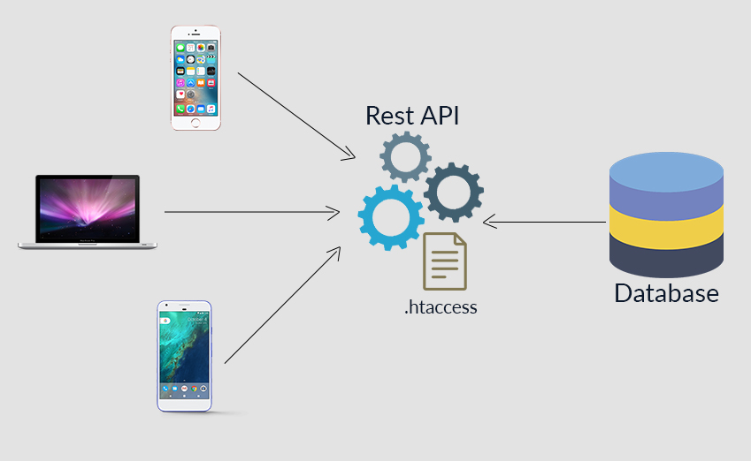
Figure 1 REST API Concept

METODOLOGI

Penyusunan tugas akhir
System development in this study was carried out based on the approach standard which includes ways, techniques and modeling inside build information systems. This is known as System Development Life Cycle (SDLC). The SDLC method used in this study is the Waterfall method. This method is used because at each stage of the study is able to accept changes and development of concepts from the previous stages, which this supports the purpose of research is to build a system that is able to adapt to the development of business processes in the future.
.

Studi literatur
At this stage the researcher collects information by conducting a study towards research that raises topics around development information systems with API concepts and REST architectural styles. Researchers too do direct communication and discuss with the employee section administration to one of the transport providers. This matter done to avoid possible mistakes in previous studies and strengthening the concepts used in research with similar cases.

Implementasi
The implementation phase in this research is carried out in several sub-processes, among others :
1. Building a system development environment.
2. Designing the structure of the table, functions and stored procedures on database.
3. Develop a back-end (coding) system and adjust it to database.
4. Design the rewrite structure on the web server..

Pengujian dan evaluasi
To ensure that the system runs according to the development plan facilitated business systems and processes, a testing scenario is needed system. In this study, testing will be divided into two test scenarios, including:
- Web Apps Testing
Software testing is a test that focuses on the functional specifications of the web apps. This test is done to test whether the application is running well or not.
- Mobile Apps Testing
Software testing is a test that focuses on the functional specifications of the web apps. This test is done to test whether the application is running well or not.

Penyusunan Buku Tugas Akhir
At this stage a report is prepared that explains the basic theories and methods used in this final project and the results of the implementation of software applications that have been made. The systematics of writing the final assignment outline includes :
- Pendahuluan
  - Latar Belakang
  - Rumusan Masalah
  - Batasan Tugas Akhir
  - Tujuan
  - Metodologi
  - Sistematika Penulisan
- Tinjauan Pustaka
- Desain dan Implementasi
- Pengujian dan Evaluasi
- Kesimpulan dan Saran
- Daftar Pustaka

JADWAL KEGIATAN
Tahapan | 2019
Tahapan | May |  |  |  | June |  |  |  | July |  |  |  | November |  |  |  | Desember
Penyusunan Proposal
Studi Literatur
Perancangan Sistem
Implementasi
Pengujian dan Evaluasi
Penyusunan Buku

DAFTAR PUSTAKA

[1] | M. K. V. P. B. Lumitha Seema Cutinha, "Automatic Cloth Retriever System," p. 4, 2016.
[2] | "WarriorNux," [Online]. Available: http://www.warriornux.com/pengertian-modul-wifi-esp8266/. [Accessed Desember 2016].
[3] | F. M. Arjitya. [Online]. Available: https://jurnal.umk.ac.id/index.php/SNA/article/viewFile/647/659. [Accessed 17 Desember 2017].
[4] | M. U. B. M. Rivan Lesmanto Kahimpong. [Online]. Available: https://ejournal.unsrat.ac.id/index.php/poros/article/download/15899/15412. [Accessed 12 Desember 2017].

